Policy Guidance
Managing policies at MLP is a six-stage process – each stage needs to be finished before moving on to the next. If you’re not sure what to do at any point, just get in touch with the Head of Governance (csawyer@magnalearningpartnership.org.uk).

- Identify Policy Type
Statutory Policies
  - The DfE’s statutory policies list for Academy Trusts is now part of the Academy Trust Governance Guide – you can find it here: https://www.gov.uk/guidance/academy-trust-governance-guide. Our full policy list is in Appendix 2
  - Statutory policies are written in line with statutory guidance and/or legislation by a senior leader – either someone within the Trust or Academy.
  - Review periods and approval levels are set out in Appendix 2, in line with statutory guidance and/or legislation
  - The Head of Governance (working with the Academy Governance Committee Clerks) and Trust/Academy Leaders are responsible for making sure all statutory policies are in place at Trust and Academy level
  - The Head of Governance will advise relevant senior leaders when a new statutory policy is needed
Non-Statutory Policies
  - Non-statutory policies are anything not on the DfE statutory list (see 1.1 above). Our Trust non-statutory policies are listed in Appendix 2
  - We may develop a non-statutory policy where it supports best practice or fills a gap not covered by statutory requirements
  - Non-statutory policies are written by someone with relevant subject knowledge, working alongside a senior leader
  - Before creating a new non-statutory policy, use Appendix 1 to work out the best approach – you might find that one of the following is more appropriate:
- Integrate with an existing policy
- Create a guidance and practice document
- Create a full policy
  - Once you’ve worked through the above, speak to the Head of Governance before starting to write any new non-statutory policy
- Identify Policy Level
Trust Policies
  - Trust policies apply to all Trust employees, volunteers and pupils, as relevant
  - Trust policies are approved by the Trust Board or a member of the executive/senior leadership team
  - Once approved, statutory policies are added to Every and are added to the MLP website (or staff page as appropriate)
  - A register of all Trust statutory policies, including approval and review dates, is held in Every and managed by the Head of Governance
Academy Policies
  - Academy policies apply to employees, volunteers and staff at the relevant academies and central, and this will be made clear in the policy wording. A template policy may be available – see Appendix 2.
  - Academy policies are approved by the Academy Leader or relevant senior leader (non-statutory) or the Academy Governance Committee (statutory)
  - Once approved, statutory policies are added to Every. Academy Leaders should let staff, pupils and parents know as appropriate
  - A register of all Academy statutory policies, including approval and review dates, is held in Every and managed by the Academy Leader

- Policy Writing
  - All policies should use the standard front cover and changes page, see Appendix 3
  - Trust policies should be on headed paper with the Trust logo
  - Academy policies should be on headed paper with the Academy and Trust logo as appropriate
  - Policies should be developed with input from relevant stakeholders, both internally and externally where appropriate
  - Stakeholders may include, but are not restricted to: Trust Board, Trust Board Committees, Academy Governance Committees, Central Team Leaders (Education, Finance and Business, Estates, Governance, HR, Safeguarding, SEND), staff, parents and pupils
  - When consulting on a new policy, also refer to sections 6.5 and 6.6 below
  - Once consultation is complete, relevant feedback should be incorporated into the policy

- Policy Approval
Trust Policies
  - Statutory policies need to be approved by a Trust Board Committee. Approval must be recorded clearly in the meeting minutes, and the Every policy register updated.
  - Non-statutory policies can be approved by the Trust executive/senior leadership team
Academy Policies
  - Statutory policies need to be approved by the Academy Governance Committee. Approval must be recorded clearly in the meeting minutes, and the Every policy register updated.
  - Non-statutory policies can be approved by the Academy Leader

- Policy Distribution
Trust Policies
  - Once approved, the Head of Governance will arrange for the policy to be uploaded to the relevant websites (e.g. Every, Trust and Academy websites)
  - The policy owner is responsible for sharing the policy with relevant people
Academy Policies
  - Once approved, the Academy Governance Committee Clerk will arrange for the policy to be uploaded to the relevant websites (e.g. Every, Academy websites)
  - The policy owner is responsible for sharing the policy with relevant people

- Policy Review
  - All policies should be reviewed regularly to keep them up to date and relevant
  - Statutory policies are reviewed in line with the relevant guidance
  - Non-statutory policies should be reviewed every three years, unless the policy owner feels an earlier review is needed
  - If a change to statutory guidance means a policy needs updating, don’t wait for the next scheduled review – the policy owner should let the Head of Governance or Academy Governance Committee Clerk know as soon as possible. Any statutory updates should then be flagged at the next meeting of the relevant policy approvers.
  - If significant changes are being proposed to a policy, it’s worth consulting with stakeholders (as per 3.5)
  - When reviewing non-statutory policies, use Appendix 1 and ask yourself the following questions:
- Why was the policy created in the first place (e.g. was it to deal with a specific issue at the time)? Is that still relevant? And if the issue hasn’t improved, is the policy actually working?
- If the policy was needed for a specific award or kitemark, do we still hold it?
- Who mainly uses this policy, and is it still shaping their work in this area?

Appendix 1 - Policy Decision Flowchart

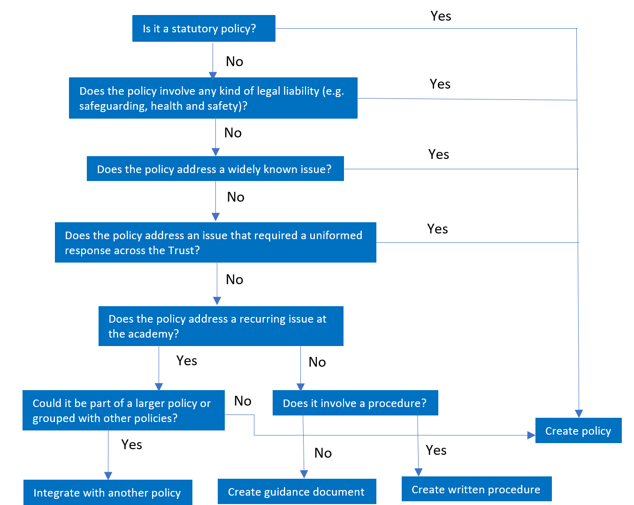

Appendix 2 – Trust and Academy Policies

Policy | Statutory/ Non Statutory | Policy Agreement | Review Cycle | Publication on Website | Review Term | Owner | Staff Handbook
Acceptable Use Policy | Non-Statutory | Executive | 3 years | No |  | Head of IT | Yes
Accessibility Plan  TEMPLATE | Statutory | AGC | 3 years | Yes  (Academy) | Term 2 | Director of Inclusion | No
Admission Arrangements | Statutory | Trust Board | Annual | Yes  (Academy) | Term 3 | Head of Governance | No
Adoption Leave Policies | Non-Statutory | Executive | 3 years | No |  | Director of HR | Yes
AI Guidance and Practice | Non-Statutory | Audit and Risk | 3 years | No | Term 5 | Head of IT | Yes
Allergy Policy  TEMPLATE | Statutory | AGC | 3 years | Yes | Term 2 | Director of Finance and Business | Yes
Anti Harassment and Bullying Policy | Non-Statutory | Executive | 3 years | No |  | Director of HR | Yes
Appraisal Policies | Non-Statutory | People and Pay | 3 years | No | Term 1 | CEO | No
Assessment Guidance and Practice | Non-Statutory | Executive | 3 years | No |  | Director of Education (Primary) | No
Attendance Policy | Statutory | Education | Annual | Yes  (Trust & Academies) | Term 5 | Director of Safeguarding and Culture | No
Behaviour Policy | Statutory | Education | Annual | Yes  (Trust) | Term 1 | Director of Safeguarding and Culture | No
Behaviour Procedures  TEMPLATE | Non-Statutory | AGC | Annual | Yes  (Academy) | Term 1 | Academy Leader | No
Business Continuity Plan | Non-Statutory | Finance and Operations | Annual | No | Term 5 | Director of Finance and Business | Yes
Capability Policy and Procedures | Non- Statutory | People and Pay | 3 years | No | Term 4 | Director of HR | No
Careers Statement | Non-Statutory | Executive | Annual | Yes  (Trust) |  | Director of Education (Secondary) | No
Careers Provider Access Statement (secondary and post 16)  TEMPLATE | Statutory | AGC | Annual | Yes  (Academy) | Term 5 | Director of Education (Secondary) | No
Charging and Remissions Policy  (Nursery version is Trust template for adoption locally) | Statutory | Finance and Operations | Annual | Yes  (Trust & Academies) | Term 2 | Director of Finance and Business | No
Collective Worship and RE Policy (church academies only)  TEMPLATE | Non-Statutory | Executive (in conjunction with Christian Mandate Governor) | 3 years | Yes  (Academy) | Term 4 | Director of Education (Secondary) | No
Complaints Procedure | Statutory | Trust Board | Annual | Yes  (Trust & Academies) | Term 5 | Head of Governance | No
Conflict of Interest Guidance and Practice | Non-Statutory | Executive | 3 years | No |  | Head of Governance | Yes
Data Protection (inc. Protection Biometric Information of Children) | Statutory | Audit and Risk | Annual | Yes  (Trust) | Term 3 | Director of Finance and Business | No
Data Retention Policy | Non-Statutory | Executive | Annual | No |  | Director of Finance and Business | No
Disciplinary Procedure | Non-Statutory | People and Pay | Annual | No | Term 4 | Director of HR | No
Early Career Teacher Guidance and Practice | Non-Statutory | Executive | 3 years | No |  | Director of Education (Primary) | No
Equality Information and Objectives | Statutory | Trust Board / AGC | 4 years with annual review | Yes  (Trust & Academies) | Term 1 / Term 2 | CEO | No
Examinations Policy (secondary)  (inc. Word Processor Policy)  TEMPLATE | Statutory | Education | Annual | Yes  (Academy) | Term 1 | Director of Education (Secondary) | No
EYFS Guidance and Practice | Non-Statutory | Executive | Annual | Yes  (Trust) |  | Director of Education (Primary) | No
Financial Controls Manual | Non-Statutory | Audit and Risk | Annual | No | Term 2 | Director of Finance and Business | No
First Aid Policy  TEMPLATE | Statutory | Executive | Annual | Yes  (Academy) | Term 2 | Director of Finance and Business | No
Flexible Working Policy | Non-Statutory | Executive | 3 years | No |  | Director of HR | Yes
Freedom of Information Policy | Statutory | Audit and Risk | Annual | Yes  (Trust) | Term 3 | Director of Finance and Business | No
Gifts and Hospitality Policy | Non-Statutory | Executive | 3 years | No |  | Director of Finance and Business | Yes
Governance Expenses Policy | Statutory | Executive | 3 years | No |  | Head of Governance | No
Grievance Policy and Procedure | Statutory | People and Pay | Annual | No | Term 4 | Director of HR | No
Health and Safety Policy | Statutory | Finance and Operations | Annual | Yes  (Trust) | Term 4 | Head of Estates | No
Information Security Policy | Non-Statutory | Audit and Risk | Annual | No | Term 3 | Head of IT | No
Investment Policy | Non-Statutory | Finance and Operations | Annual | No | Term 2 | Director of Finance and Business | No
Lettings Policy | Non-Statutory | Executive | 3 years | Yes  (Trust) |  | Director of Finance and Business | No
Lockdown Procedure  TEMPLATE | Non-Statutory | AGC | Annual | No | Term 1 | Director of Finance and Business | No
Lone Working Guidance and Practice | Non-Statutory | Executive | 3 years | No |  | Director of HR | Yes
Looked After Children Policy | Non-Statutory | Executive | Annual | Yes  (Trust) |  | Director of Inclusion | No
Managing Concerns and Complaints against Trustees/Governors Procedure | Non-Statutory | Executive | 3 years | No |  | Head of Governance | No
Maternity Leave Policies | Non-Statutory | Executive | 3 years | No |  | Director of HR | Yes
Menopause Guidance and Practice | Non-Statutory | Executive | 3 years | No |  | Director of HR | Yes
Mobile Phone Policy  TEMPLATE | Statutory | AGC | Annual | Yes  (Trust & Academies) | Term 1 | Director of Safeguarding and Culture | Yes
Online Safety Policy  TEMPLATE | Statutory | AGC | Annual | Yes  (Academy) | Term 1 | Head of IT | No
Parent Code of Conduct | Non-Statutory | Executive | 3 years | Yes  (Trust) |  | Director of Safeguarding and Culture | No
Parental and Shared Parental Leave Policies | Non-Statutory | Executive | 3 years | No |  | Director of HR | Yes
Paternity Leave Policy | Non-Statutory | Executive | 3 years | No |  | Director of HR | Yes
Pay Policy | Non-Statutory | People and Pay | Annual | No | Term 6 | Director of Finance and Business | Yes
Premises Management Policy | Statutory | Finance and Operations | Annual | No | Term 4 | Director of Finance and Business | No
Probation Policy | Non-Statutory | Executive | 3 years | No |  | Director of HR | Yes
Recruitment Policy | Non-Statutory | Executive | 3 years | No |  | Director of HR | No
Redundancy and Redeployment Policy | Non-Statutory | Executive | 3 years | No |  | Director of HR | Yes
Relationships (and Sex) Education Policy (primary and secondary)  TEMPLATE | Statutory | AGC | Annual | Yes  (Academy) | Term 2 | Director of Education (Secondary) | No
Reserves Policy | Non-Statutory | Finance and Operations | Annual | No | Term 2 | Director of Finance and Business | No
Risk Management Policy | Non-Statutory | Audit and Risk | 3 years | No | Term 5 | Director of Finance and Business | No
Safeguarding Statement | Non-Statutory | Trust Board | Annual | Yes | Term 1 | Director of Safeguarding and Culture | No
Safeguarding & Child Protection Policy  TEMPLATE | Statutory | AGC | Annual | Yes  (Academy) | Term 1 | Director of Safeguarding and Culture | No
School Uniform Policy (primary and secondary)  TEMPLATE | Statutory | AGC | Annual | Yes  (Academy) | Term 4 | Director of Education (Primary) | No
SEND Information Report/Inclusion Strategy  TEMPLATE | Statutory | AGC | Annual | Yes  (Academy) | Term 2 | Director of Inclusion | No
SEND Policy | Statutory | Education | Annual | Yes  (Trust & Academies) | Term 3 | Director of Inclusion | No
Separated Families Guidance and Practice | Non-Statutory | Executive | 3 years | Yes |  | Director of Safeguarding and Culture | No
Sickness Absence Policy | Non-Statutory | Executive | 3 years | No |  | Director of HR | Yes
Staff Code of Conduct | Statutory | People and Pay | Annual | No | Term 6 | Director of HR | Yes
Supporting Pupils at School with Medical Conditions Policy  TEMPLATE | Statutory | AGC | Annual | Yes  (Academy) | Term 2 | Director of Finance and Business | No
Supporting Pupils with Medical Conditions who Cannot attend School Policy | Non-Statutory | Executive | 3 years | Yes  (Trust) |  | Director of Inclusion | No
Suspension and Exclusion Policy | Statutory | Education | Annual | Yes  (Trust & Academies) | Term 5 | Director of Safeguarding and Culture | No
Use of Restrictive Interventions Policy  TEMPLATE | Statutory | Executive | 3 years | Yes  (Academy) |  | Director of Safeguarding and Culture | No
Whistleblowing Policy | Statutory | Trust Board | 3 years | Yes  (Trust & Academies) | Term 5 | Head of Governance | No
Young Carers Policy  TEMPLATE | Non-Statutory | Executive | 3 years | Yes  (Academy) |  | Director of Safeguarding and Culture | No

Appendix 3 – Policy Cover/Changes Template

Date of last review: |  | Review period:
Date of next review: |  | Owner:

Trust/Academy Logos

Policy Name

Empowering People – Shaping the Future

History of Policy Changes:

Date | Page | Change | Origin of Change

Reference to Trust/Academy values

